Name: Khuzaim Adnan Qureshi
Roll number: 233587
Full Stack Web Development Lab Final
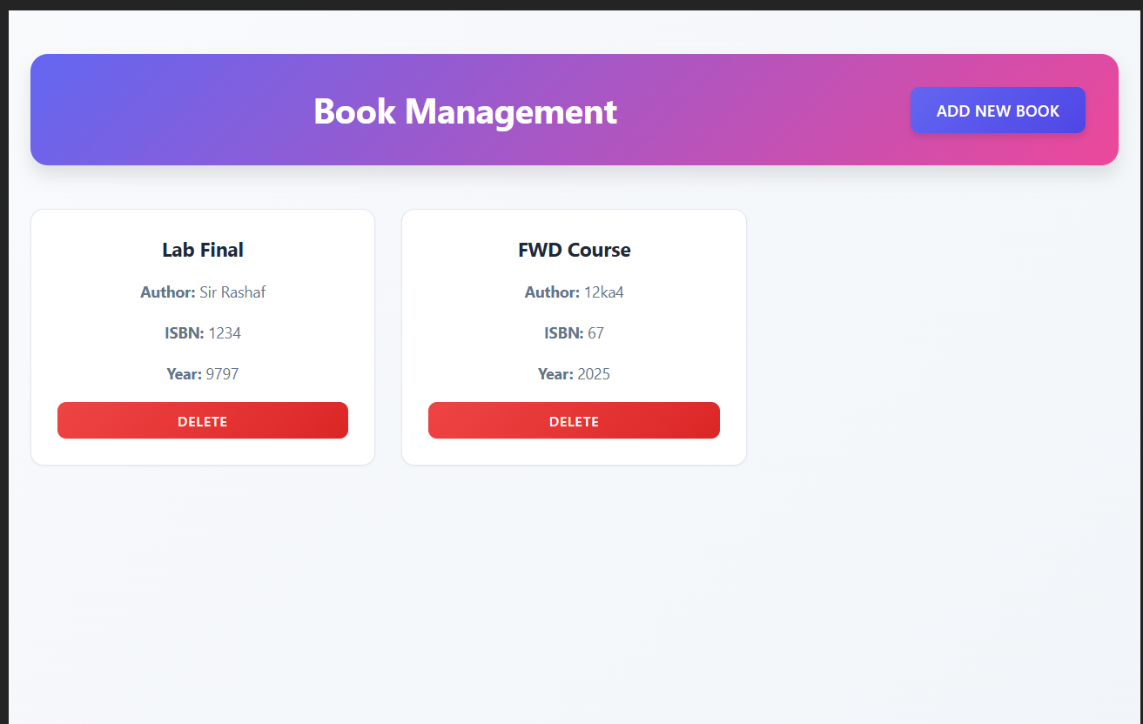
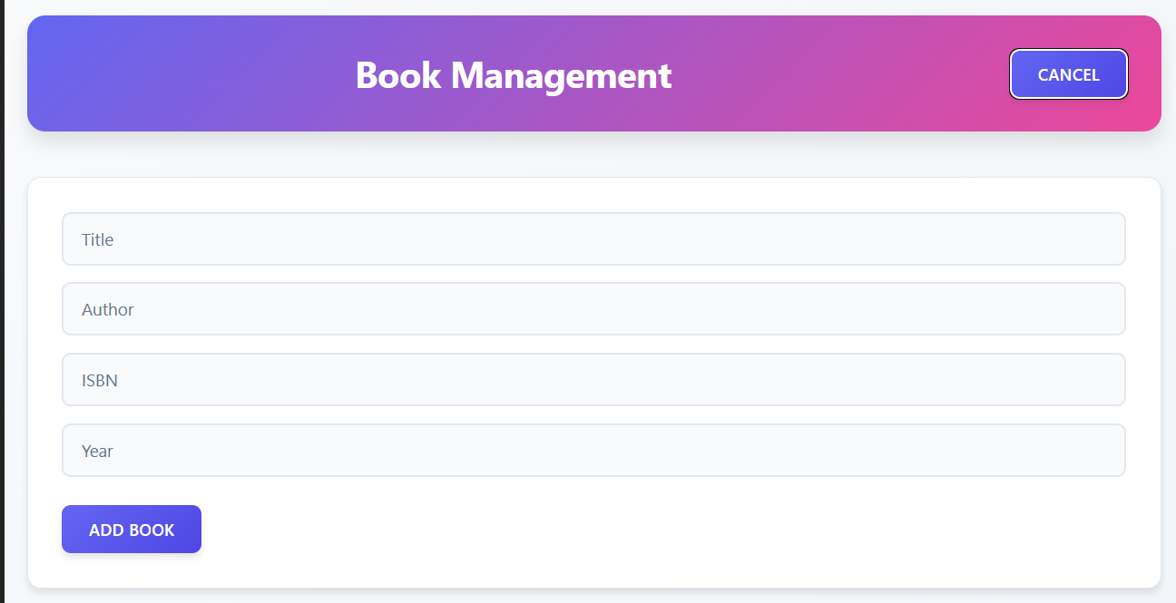

GitHub Repo Link
https://github.com/Khuzaim123/FWDLABFinal

